22nd Arab Cultural Festival
SF Union Square - Sat Oct 7th 2017 - 11 AM - 6 PM
www.arabculturecenter.org
events@arabculturecenter.org

ARAB CULTURAL FESTIVAL Donation Form
ACF is excited to showcase the music, art, goods and foods of the Arab world in Union Square at our 22nd Annual Arab Cultural Festival on Saturday, October 7th, 2017. We hope you and your business or organization will take advantage of the opportunity to sell and exhibit your goods to over 10,000 people.

To keep our event free and accessible to the public, we need your support.

Yes, we like to support the 20th Annual Arab Cultural Festival by giving a tax-deductible donation of

____ $500 ____ $250 ____ $100 ____ Other $......
Check # _______
Call me, I like to pay by a Credit Card ( ) ____-_______

Organization Name: ______________________________________________________
Contact Person: __________________________________________________________
Website: ________________________________ Email: _______________________________
Phone: ________________________. Did you participate in prev. Arab Festivals: _______
Address: ______________________________________________________ Zip: __________
My name to be listed as __________________________________________________

If you have any questions, please email us and we will gladly answer your questions

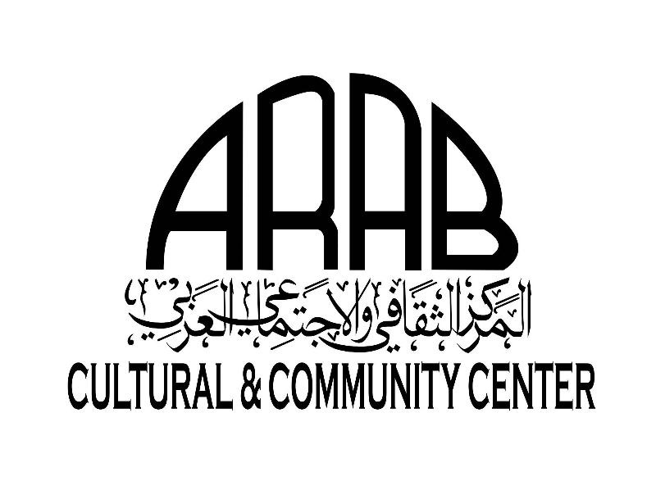 Arab Cultural Festival c/o Arab Cultural Center
2 Plaza St. San Francisco, CA 94116415-664-2200 Fax 415-664-2280

ACCC is a certified non profit organization with a 501C tax ID number. All of your donation will be a tax deductible. Tax documents will be furnished to all sponsors

